1. 1. SSH to the **haproxyVM on Azure or any of the master NODE** of the 3 AWS Clustersand run the below command to deploy the Granfa and Prometheus deployments in a separate namespace.

|  |
| --- |
| $ sudo su  # kubectl apply --filename https://raw.githubusercontent.com/giantswarm/kubernetes-prometheus/master/manifests-all.yaml |

This will create the namespace **monitoring** and bring up all above components in there.

2. Now, run the below command to get the grafana and prometheus pod details.

|  |
| --- |
| $ kubectl get pods -n monitoring -o wide |

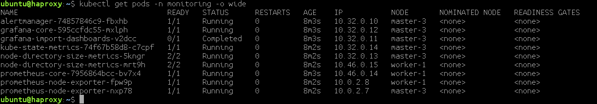

**Node IP** is the IP of the **NODE** where the pod (**Grafana-core**) is deployed, in this example **master-3**.

3. Now, to check the NODEPORT where the **Grafana-core** has been deployed,

|  |
| --- |
| $ kubectl get svc -n monitoring |

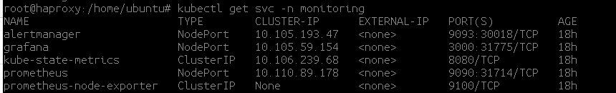

We can observe from the above output that the Grafana is exposed on port **31775** in our example and is running on NODE **master-3**

4. Now, goto the Azure Portal/AWS and and copy the public IP of the **NODE** where the grafana is deployed, and access the **Grafana dashboard** with the <Public-IP>:Port

Ex. <http://104.211.180.209:31775>

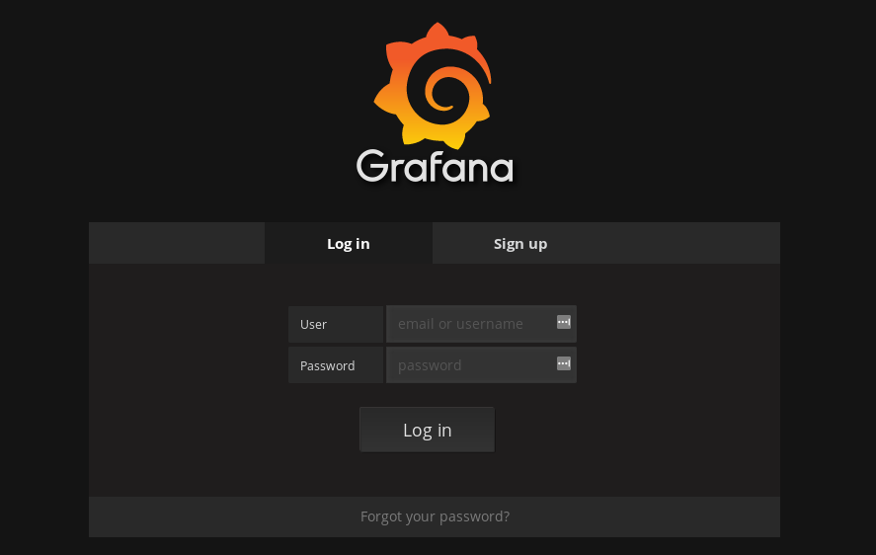

The default login credentials for the Grafana Dashboard are

Username : admin

Password : admin

**5. Import Kubernetes cluster monitoring**

* Grafana UI / Dashboards / Import

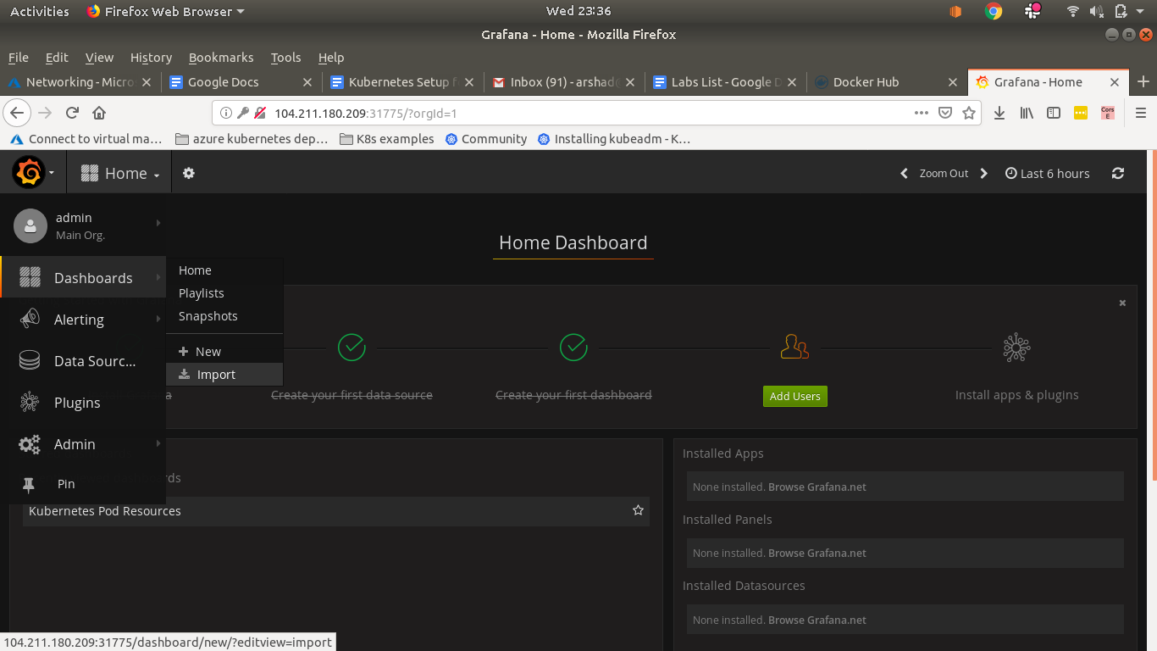

* Paste the url in Grafana.net Dashboard: <https://grafana.com/dashboards/315>

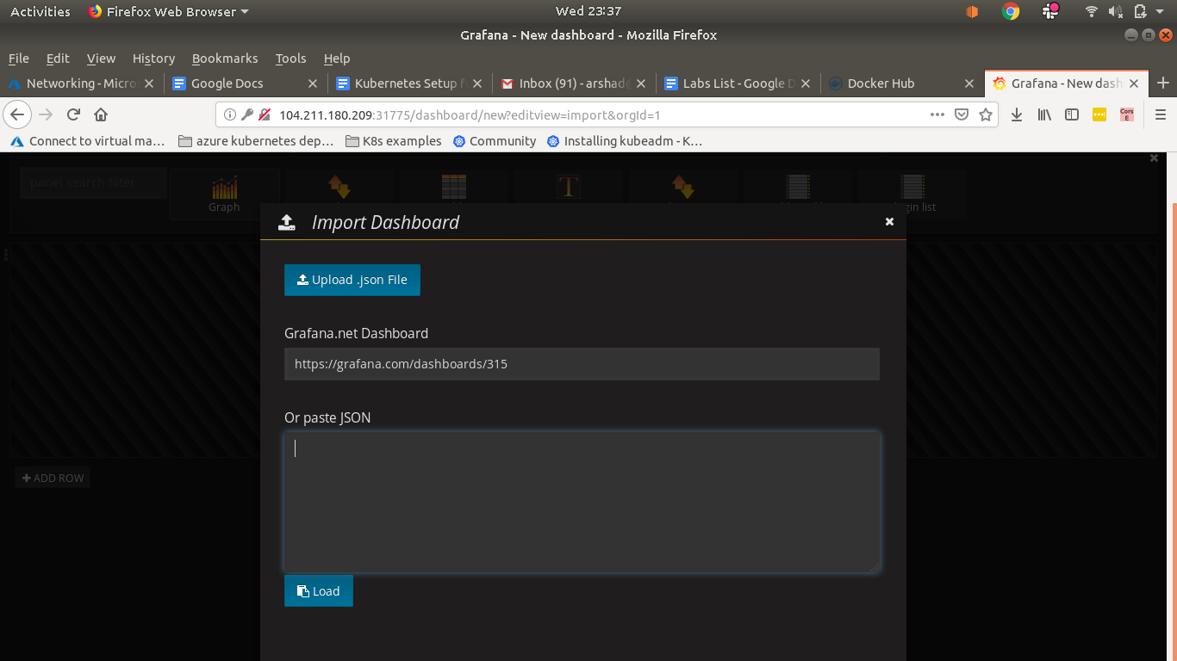

* Load

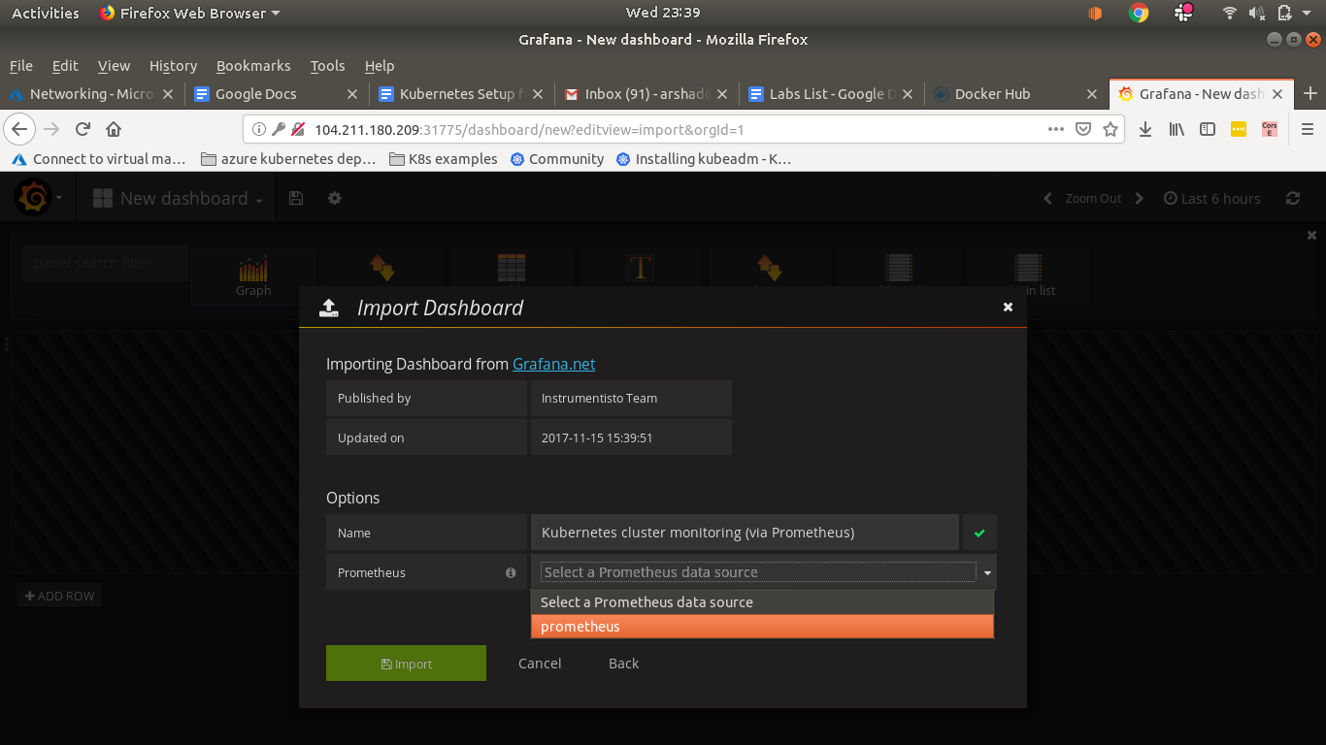

* Prometheus: prometheus
* Import

